Assignment -1
Task -1
Description: Install and configure GitHub Copilot in VS Code. Take screenshots of each step.
Expected Output: Install and configure GitHub Copilot in VS Code. Take screenshots of each step.
Prerequisites: Latest version of VS Code is installed, GitHub Account, Internet Connection
Step 1: Open VS Code
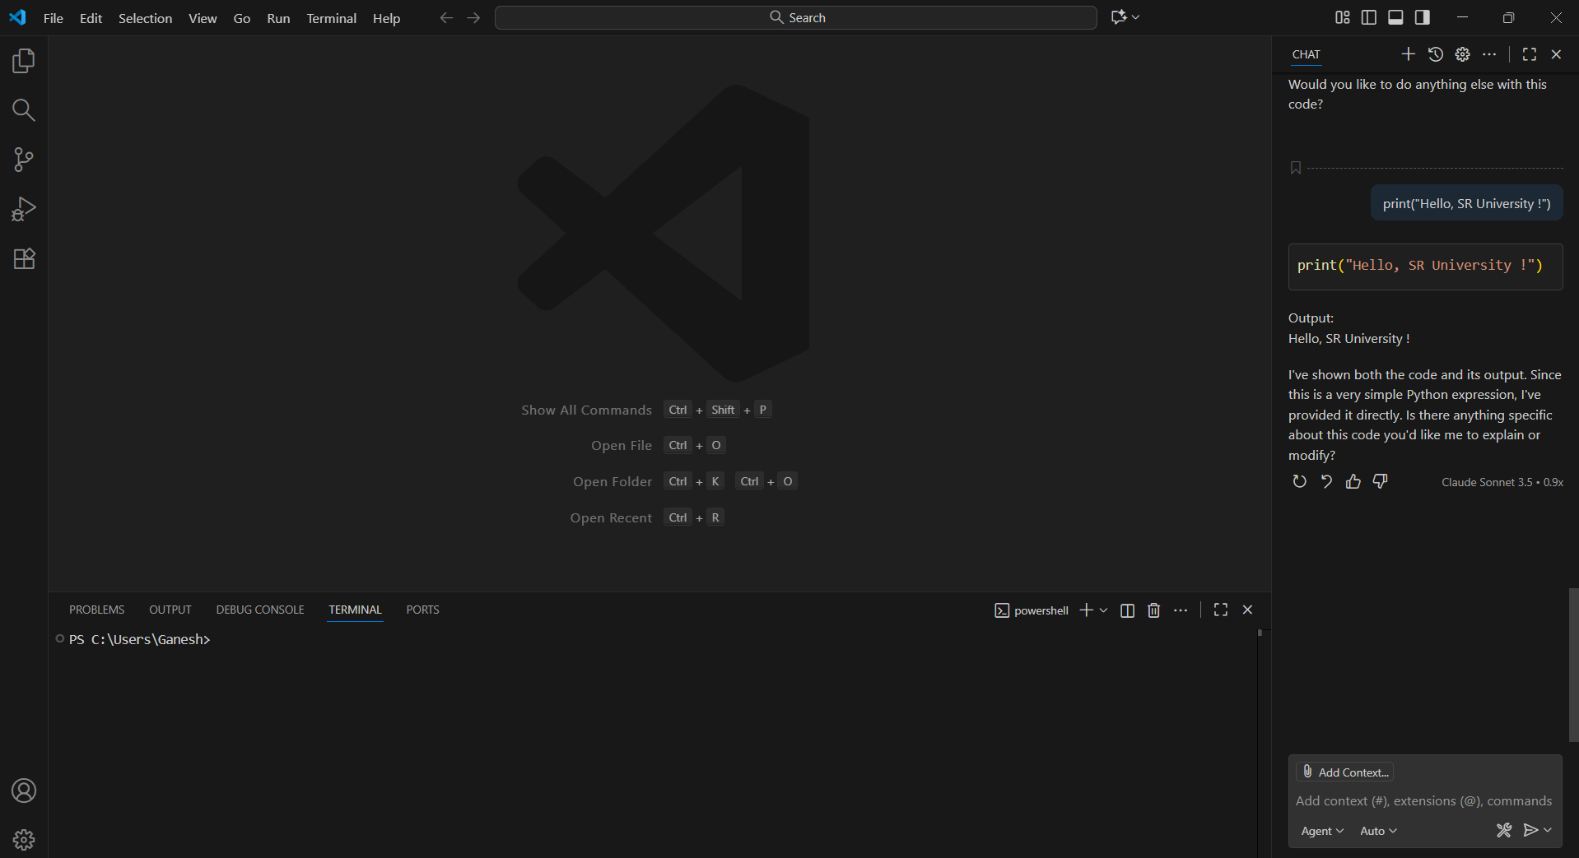
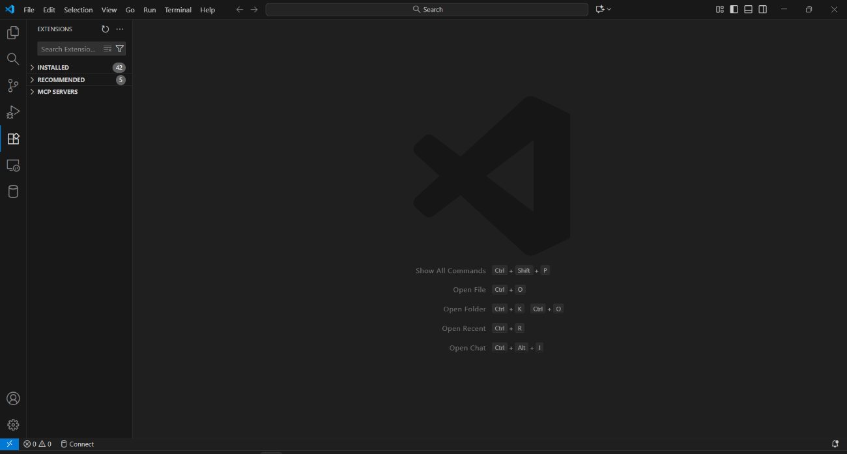
Step 2: Open the Extensions Tab

Step 3: Search for “GitHub Copilot”
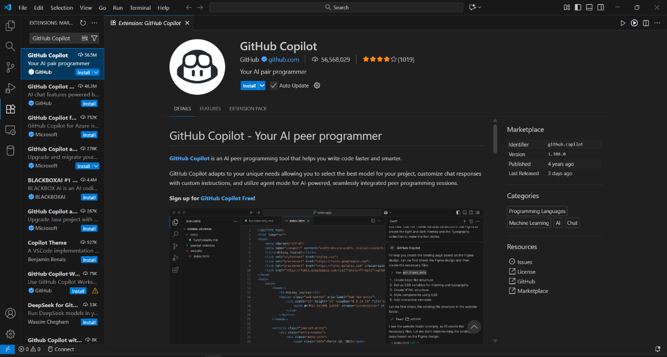
Step 4: Click on “Install” and wait for VS Code to install the GitHub Copilot Extension
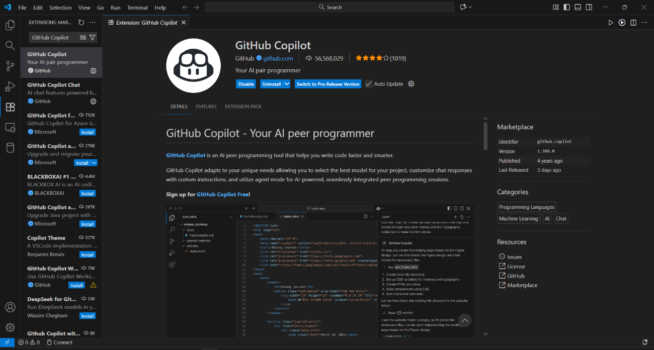

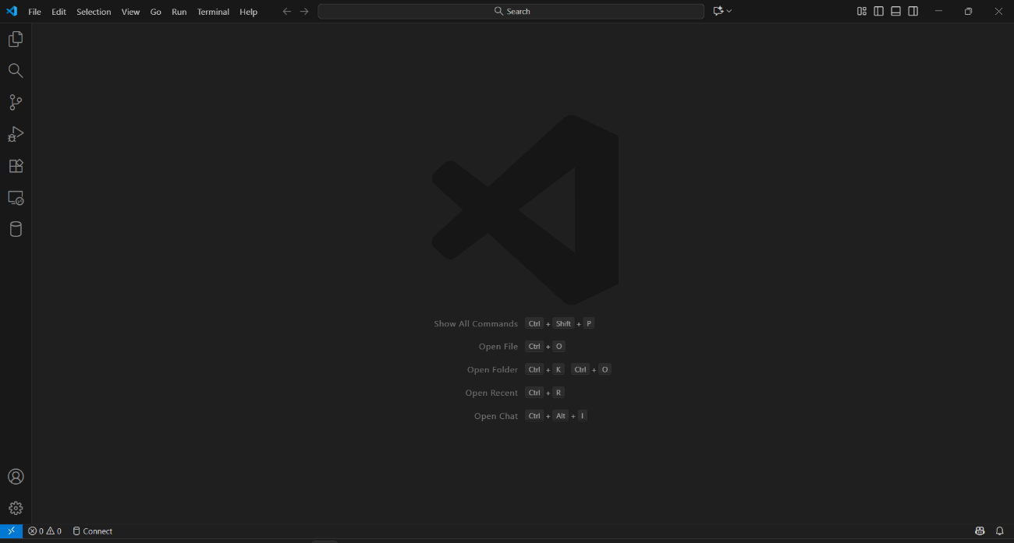
Step 5: Close and Reopen VS Code

Step 6: Sign-in and Authorize GitHub Copilot using the GitHub account
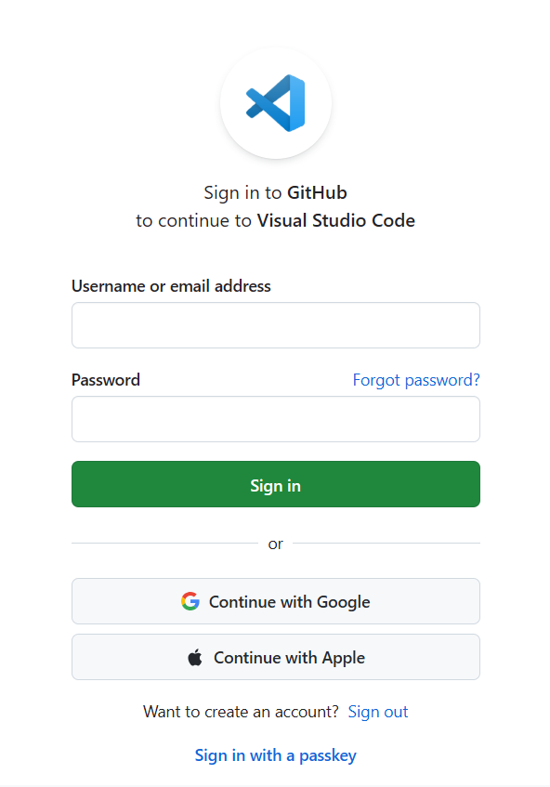

Step 7: GitHub Copilot is now Ready!

Task - 2
Description: Use Copilot to generate a is_prime() Python function.
Prompt : Provide me a Function to check if a number is prime

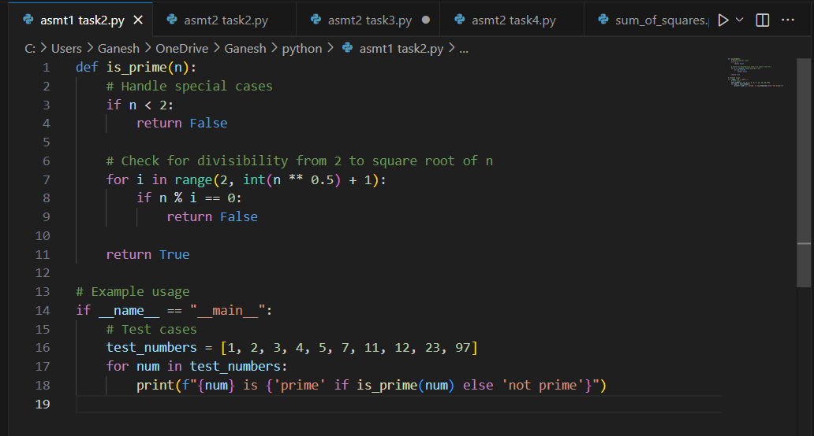
Expected Output: Function to check primality with correct logic.
Practical Output:

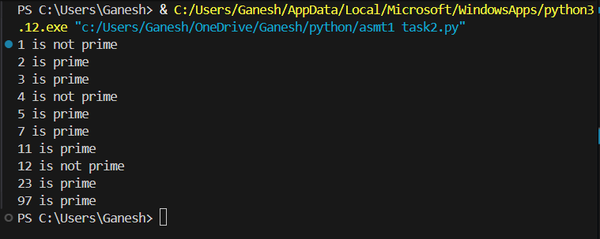

Task 3
Description: Write a comment like # Function to reverse a string and use Copilot to generate the function.
Prompt: Give me a function to reverse a string
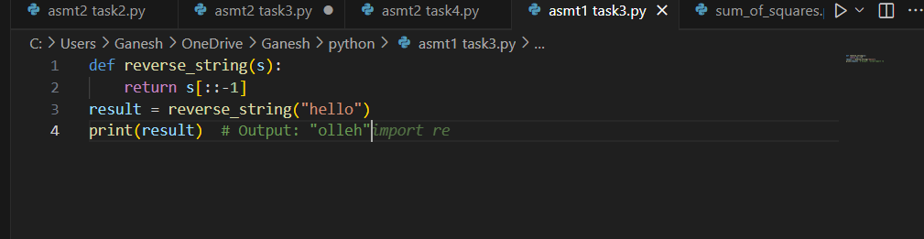
Expected Output: Auto-completed reverse function
Practical Output:

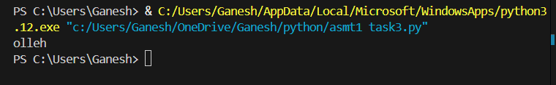

Task 4

Description: Generate both recursive and iterative versions of a factorial function using comments.
Prompt: Write a Python function to compute factorial using recursion and iteration with user input
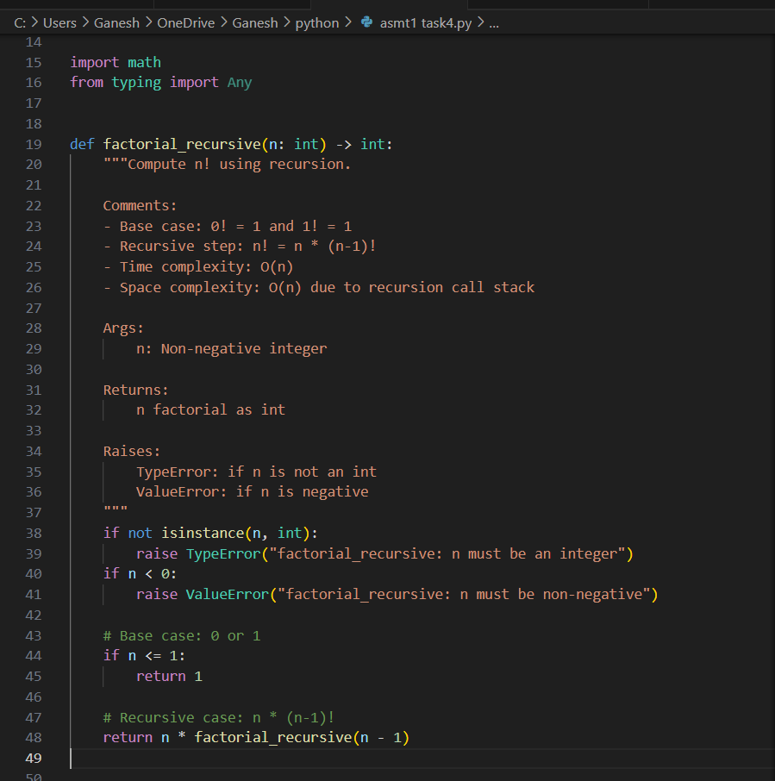

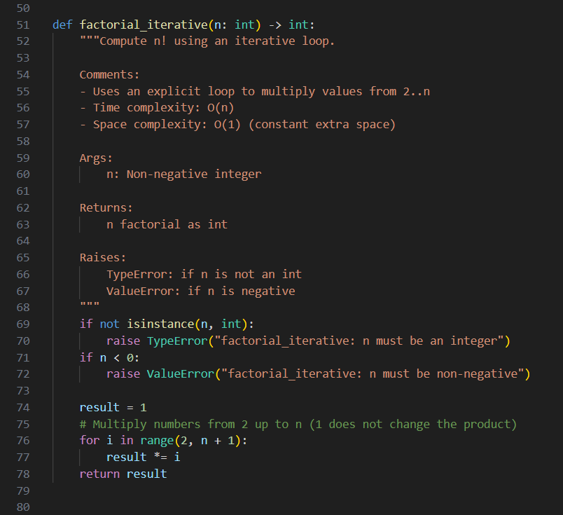
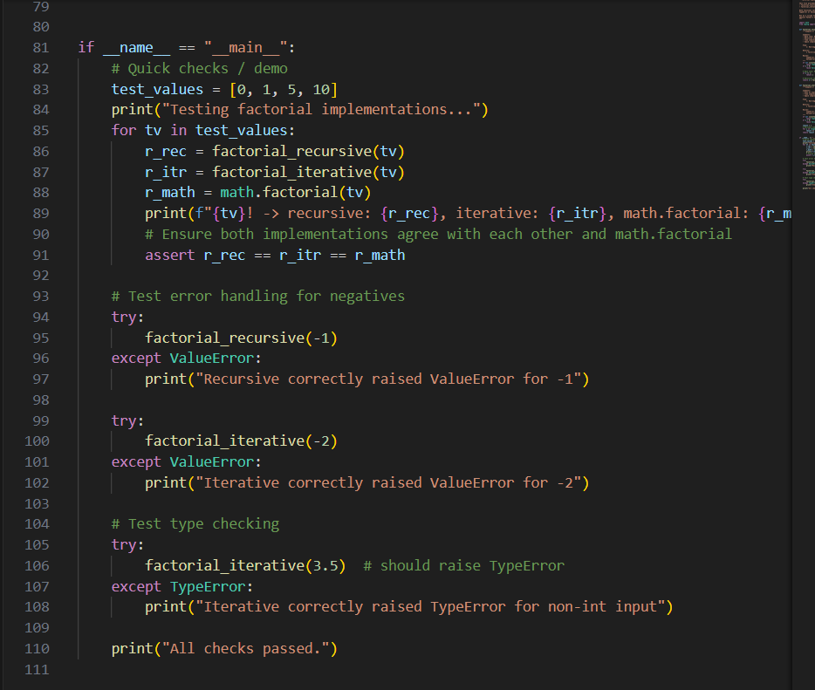
Expected Output: Two working factorial implementations
Practical Output:

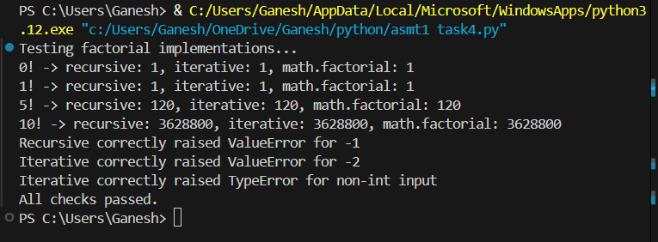

Task 5

Description: Use Copilot to find the largest number in a list. Assess code quality and efficiency.
Prompt: To finfd a largest number in the list Then assess the code quality and efficiency.
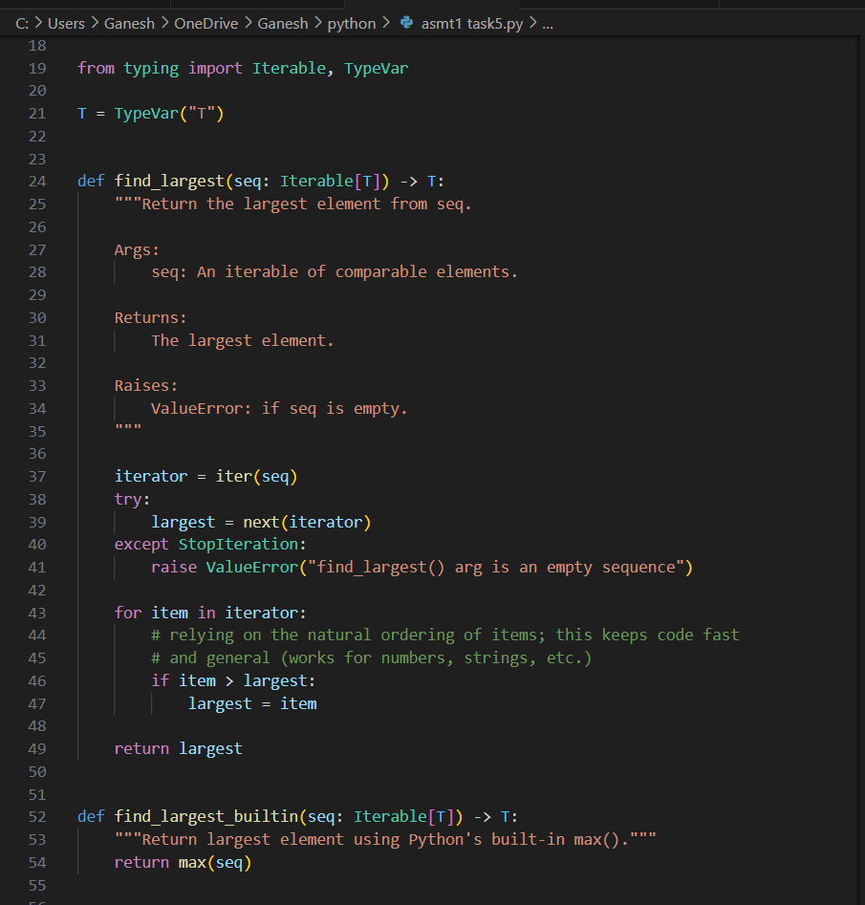
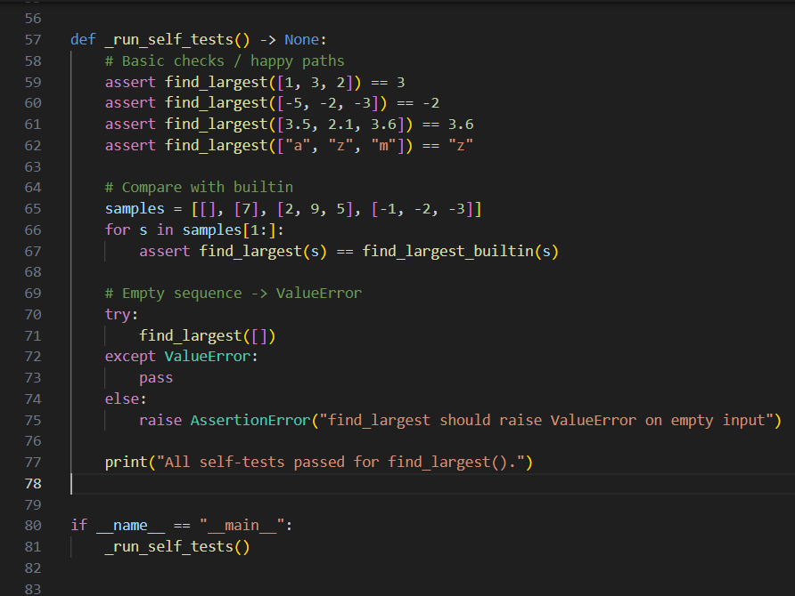
Expected Output: A valid function with your review
Practical Output:

